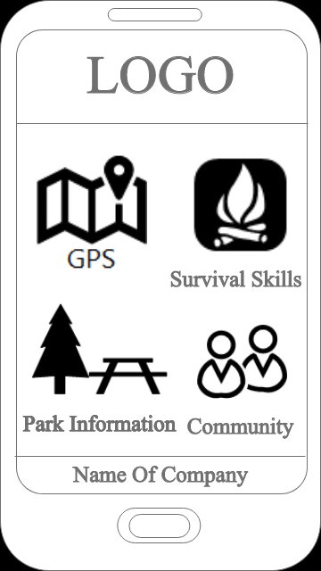**Page Description:**

This is the main page of our app.

It provides the user access to the GPS, Community,

Park Information and Survival Skills.

**User Action:**

User have to enter to the app.

**Business Rules:**  
Display a default logo at the top and the name of company at the

bottom.

User have ability to view all icons-buttons on the screen.

User can access only one icons-buttons at time.

To exit app user, have to click the button on the phone.

**Potential Enhancements/Changes/Issues:**

Provide to the user ability to login into device.

**Main Page Summary:** The presented page shows the main page

of app that includes four icons-buttons that will provides different pages with interaction to the user.

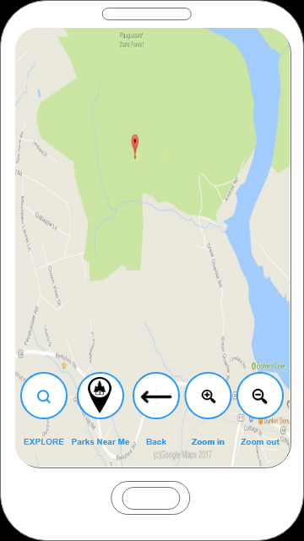**Page Description:**

This is the GPS. Here user can see map, zoom in/out buttons, back button, search button and button with picture of location sign with a tree inside.

**User Action:**

User have to enter to the app and choose GPS.

**Business Rules:**

All buttons are locating by default at the bottom.

Only one bottom works at one time.

Search window is hidden as long as user didn’t click Explore button.

**Potential Enhancements/Changes/Issues:**

Provide an exit button.

**Main Page Summary:**

To find path in park user have to click at the Explore bottom.

To find parks that near user location, user have to click on the

Bottom Parks Near me.

To return user have to click at the error.

To return on the main page user have to click at the return button at the phone.

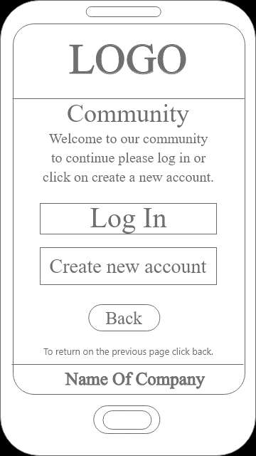**Description:**

This is the GPS. Here user can see map, zoom in/out buttons,

back button, search button and button with picture of

location sign with a tree inside.

**User Action:**

User have to enter to the app and choose GPS.

**Business Rules:**

All buttons are locating by default at the bottom.

Only one bottom works at one time.

Search window is hidden as long as user didn’t

click Explore button.

**Potential Enhancements/Changes/Issues:**

Provide an exit button.

**Main Page Summary:**

To find path in park user have to click at the Explore

bottom.

To find parks that near user location, user have to

click on the

Bottom Parks Near me.

To return user have to click at the error.

To return on the main page user have to click at the return

button at the phone.

